Warning – AutoPark – CGEA1.3

Functional Description

The purpose of the AutoPark Warning Feature (also called Active Park Assist) is to provide step-by-step guidance to the driver during an AutoPark maneuver. During an AutoPark maneuver, the AutoPark feature (SAPP Controller = PAM) controls the vehicle steering system and the driver retains direct control of vehicle motion (throttle pedal, brake, gear selection). The driver is guided by the SAPP controller via text messages, chimes from the Front and Rear Park Aid systems, and Autopark (Activepark) Chimes.

In S-HMI vehicles, the text messages have moved from the message center to the center stack display for North America. This leaves the cluster responsible for just one warning display (ACTIVE PARK FAULT) related to AutoPark, as well as the chime arbitration. This is different from the MY 10 implementation where the warnings were in the message center. There is further complexity for GCC. For MY 15 GCC, the text messages all remain in the cluster as well as the chime arbitration. This is only due to APIM Arabic translation issues. When in GCC countries, the text messages will only show when Arabic is the selected language.

The HMI (text messages) in the cluster covers both Parallel AutoPark and Perpendicular Autopark. There are no unique cluster requirements for Side Park Aid.

Starting with CD4.2, all programs have a new CAN signal defined (ApaChime_D_Rq). This signal will directly request an Autopark chime, instead of having the cluster map the chime request to SAPPStatusCoding. This allows PAM to have flexibility for chimes in various markets. When this signal is used, states 0x1 and 0x2 of AutoPark_Cfg have the identical function.

Also, the European versions of cluster have a settings menu (Chime -> Park Slot found on/off) that allows the user to disable the Active Park Space Found chime.

The AutoPark Warning Function correlates the SAPPStatusCoding (legacy) or the ApaSys_D_Stat signal to determine when to display the AutoPark warning message. ApaChime_D_Rq signal is used to determine when to sound the various Autopark chimes.

Interfaces

Interface Context Diagram (I/O Block Diagram)

Figure 1 AutoPark Warning Context Diagram
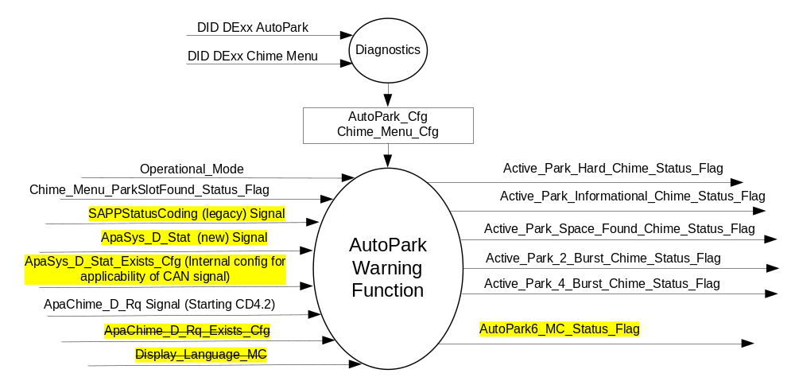

Inputs
      - INTERNAL:
    - Operational_Mode
    - AutoPark_Cfg
    - ApaSys_D_Stat_Exists_Cfg (Internal config for whether a program supports CAN signal ApaSys_D_Stat)
    - Display_Language_MC (from Display Language Selection Control Function STSS)
    - Chime_Menu_Cfg
    - Chime_Menu_ParkSlotFound_Status_Flag
- MUX messages on the CAN Bus from the PAM

- SAPPStatusCoding (legacy) Signal
Signal Name | Size (bits) | Detail | Units | Res | Offset | State Encoded | Min | Max
SAPPStatusCoding | 8 |  | unitless | 1 | 0 |  | 0 (0x0) | 255  (0xFF)

- ApaSys_D_Stat (new) Signal
Signal Name | Size (bits) | Detail | Units | Res | Offset | State Encoded | Min | Max
ApaSys_D_Stat | 3 |  | SED | 1 | 0 |  | 0 (0x0) | 7  (0x7)
 |  | Null |  |  |  | (0x0)
 |  | Off |  |  |  | (0x1)
 |  | On |  |  |  | (0x2)
 |  | Overspeed |  |  |  | (0x3)
 |  | ApaCancelled |  |  |  | (0x4)
 |  | NotAccessible |  |  |  | (0x5)
 |  | Finished |  |  |  | (0x6)
 |  | Faulty |  |  |  | (0x7)

- Table 2.0 ApaChime_D_Rq Signal
Signal Name | Size (bits) | Detail | Units | Res | Offset | State Encoded | Min | Max
ApaChime_D_Rq | 3 |  | SED | 1 | 0 |  | 0 (0x0) | 7  (0x7)
 |  | No_Chime |  |  |  | (0x0)
 |  | Spot_Found_Chime |  |  |  | (0x1)
 |  | Spot_Ready_Chime |  |  |  | (0x2)
 |  | Stop_Now_Chime |  |  |  | (0x3)
 |  | Finish_Chime |  |  |  | (0x4)
 |  | Warning_Chime |  |  |  | (0x5)
 |  | Not_Used |  |  |  | (0x6)
 |  | Not_Used |  |  |  | (0x7)

Outputs
- Active_Park_Hard_Chime_Status_Flag, internal flag to the Chime Arbitrator
- Active_Park_Informational_Chime_Status_Flag, internal flag to the Chime Arbitrator
- Active_Park_Space_Found_Chime_Status_Flag, internal flag to the Chime Arbitrator
- Active_Park_2_Burst_Chime_Status_Flag, internal flag to the Chime Arbitrator
- Active_Park_4_Burst_Chime_Status_Flag, internal flag to the Chime Arbitrator
- AutoPark6_MC_Status_Flag, used to control the Warning displayed in the message center.

Function/Performance

Operational Modes

Current Operating Mode | Functionality In Current Operating Mode
Sleep Mode | Off
Limiting Mode | Off
Normal Mode | AutoPark Warning Messages and Chimes On/Off
Crank Mode | AutoPark Warning Messages and Chimes On/Off

The above table references the setting of the Warning flag as per this section. However, the actual warning display operational modes are displayed in the Message Center section of this SPSS.

Voltage Levels

Refer to the Cluster Features Table located in the Operational Modes and Voltage Range Strategies Section of this SPSS.

Human-Machine Interface

Visual

Indicator Graphics / Display Format
Refer to Message Center Function description reference appropriate program "Global Message List.xls" Message ID W306.

1.3.3.1.2 Indicator Color Coordinates

Reference section COLOR & ILLUMINATION REQUIREMENTS (GRAPHICS).

Audio

Refer to the Chimes & Chime Arbitrator Section in this SPSS. Selected Autopark displays are associated with chimes, as specified in Tables in Section 1.3.5.1.

Switch Control Logic

None.

System Accuracy

Within 100 msec of receiving a message that results in a change of state the cluster will update the output flag to the proper state.

Operation: Performance and Functional

Subsystem Algorithm Flowchart / State Diagram

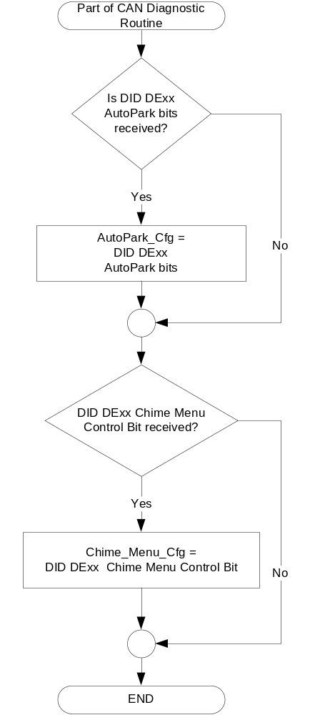

- State Matrix for AutoPark Chime Status Flags (All Regions)
Operational_ Mode | AutoPark_Cfg | ApaChime_D_Rq_Exists_Cfg | Chime_Menu_Cfg | Chime_Menu_ParkSlotFound_Status_Flag | ApaChime_D_Rq  Signal | Active_Park_Hard_Chime_Status_Flag | Active_Park_Informational_Chime_Status_Flag | Active_Park_Space_Found_Chime_Status_Flag | Active_Park_2_Burst_Chime_Status_Flag | Active_Park_4_Burst_Chime_Status_Flag
Normal  Or  Crank | Enabled NA (0x1)  OR  Enabled ECE (0x2)  OR  Enable HMI In Cluster (0x3) | True  (0x1) | X | X | 0 (0x0) “No_Chime” | Inactive | Inactive | Inactive | Inactive | Inactive
Normal  Or  Crank |  | True  (0x1) | 0x0 | X | 1 (0x1) “Spot_Found_Chime” | Inactive | Inactive | ACTIVE | Inactive | Inactive
Normal  Or  Crank |  | True  (0x1) | 0x1 | Chime Play (0x0) | 1 (0x1) “Spot_Found_Chime” | Inactive | Inactive | ACTIVE | Inactive | Inactive
Normal  Or  Crank |  | True  (0x1) | 0x1 | Chime Quiet (0x1) | 1 (0x1) “Spot_Found_Chime” | Inactive | Inactive | Inactive | Inactive | Inactive
Normal  Or  Crank |  | True  (0x1) | X | X | 2 (0x2) “Spot_Ready_Chime” | Inactive | Inactive | Inactive | ACTIVE | Inactive
 |  |  |  |  | 3 (0x3) “Stop_Now_Chime” | Inactive | Inactive | Inactive | Inactive | ACTIVE
 |  |  |  |  | 4 (0x4) “Finish_Chime” | Inactive | ACTIVE | Inactive | Inactive | Inactive
 |  |  |  |  | 5 (0x5) “Warning_Chime” | ACTIVE | Inactive | Inactive | Inactive | Inactive
 |  |  |  |  | 6 (0x6) “NotUsed” | Inactive | Inactive | Inactive | Inactive | Inactive
 |  |  |  |  | 7 (0x7) “NotUsed” | Inactive | Inactive | Inactive | Inactive | Inactive
 |  |  |  |  | Missing as per 1.4.1 | Inactive
All Other Cases |  |  |  |  |  | Inactive | Inactive | Inactive | Inactive | Inactive

.

- State Matrix for Autopark Message Center Warnings**
Operational_Mode | AutoPark_Cfg | ApaSys_D_Stat_Exists_Cfg | SAPPStatusCoding  (Legacy signal) | ApaSys_D_Stat  (New signal) | AutoPark6_MC_Status_Flag
Normal  or  Crank | Enabled NA (0x1)  OR  Enabled ECE (0x2)  OR  Enable HMI In Cluster (0x3) | False (0x0) | 6 (0x6) | X | Active  (W306)
Normal  or  Crank |  | False (0x0) | Missing as per 1.4.1 | X | Inactive
Normal  or  Crank |  | True  (0x1) | X | Faulty (0x7) | Active  (W306)
 |  |  |  | Missing as per 1.4.1 | Inactive
All Other Cases |  |  |  |  | Inactive
**Notes:
- Vehicle programs are migrating toward using ApaSys_D_Stat insead of SAPPStatusCoding.
- AutoPark6_MC_Status_Flag maps to W306.

Operation Description (supports algorithm flowchart /state diagram)

- For definition of how the Message Center arbitrates and displays Active warnings, see the Warning / Alert Display Logic Diagram, located in the Message Center – X Display with W Button Interface section of this SPSS (where X and W are appropriate values in this document).

Function Safety Classification (EMC)

Class B

Memory Storage

Parameter Name | Description | Value at  Battery Connect | Value at  Module Wake-up
AutoPark_Cfg | Configure cluster for AutoPark feature (set at VOPS end of line) | Do Not Init | Do Not Init
SAPPStatusCoding Signal | Legacy input signal received from PAM to trigger Fault warning | NoMessage  (0x1) | NoMessage  (0x1)
ApaSys_D_Stat Signal | New input signal received from PAM to trigger Fault warning | Null (0x0) | Null (0x0)
ApaSys_D_Stat_Exists_Cfg | Logical configuration parameter used to determine if particular program supports CAN signal ApaSys_D_Stat. This needs to be a physical bit in software. (Ideally set on a per program basis). The first use of this signal is B479/C519, but other programs such as CD will continue to use SAPPStatusCoding for several years.  Default from supplier is False (0x0) for CDxx, and True (0x1) for any major new program or MCA such as B479/C519, U55x, etc. | Do Not Init | Do Not Init
ApaChime_D_Rq Signal | Input signal received from PAM to request chime. Should be standard in all new programs in MY15+ starting with CD4.2. | No_Chime (0x0) | No_Chime (0x0)
ApaChime_D_Rq_Exists_Cfg | Logical configuration parameter used to determine if particular program supports CAN signal ApaChime_D_Rq. This does NOT have to be a physical bit in software. (Once it is known that signal is supported, only need to follow Table 1.2c for chimes). The only program expected to NOT support this CAN signal is CD4.1. All others are expected to support. Thus, this parameter is a mechanism for 1 STSS to support both designs. Default from supplier is False (0x0) for CD4.1, and True (0x1) for all other programs. | Do Not Init | Do Not Init
Active_Park_Hard_Chime_Status_Flag | Chime Arbitrator flag | Inactive | Inactive
Active_Park_Informational_Chime_Status_Flag | Chime Arbitrator flag | Inactive | Inactive
Active_Park_Space_Found_Chime_Status_Flag | Chime Arbitrator flag | Inactive | Inactive
Active_Park_2_Burst_Chime_Status_Flag | Chime Arbitrator flag | Inactive | Inactive
Active_Park_4_Burst_Chime_Status_Flag | Chime Arbitrator flag | Inactive | Inactive
Display_Language_MC | Output that controls language of text displays shown to the driver. Defined in Display Language Selection Control Function STSS. | As per Display Language Selection Control Function STSS. | As per Display Language Selection Control Function STSS.
Operational_Mode | 4 state indicator for cluster oper. mode | Limited | Limited or Normal or Crank
Chime_Menu_Cfg | State indicator for feature presence controlled via CAN at EOL at VO plant. Set to disabled at Cluster Supplier Manufacturing Plant | Use Stored Value | Use Stored Value
Chime_Menu_ParkSlotFound_Status_Flag | Status Flag indicating the state of the Chime -> Park Slot found on/off setting | Chime Play (0x0) | Do Not Init

Prove Out

No.

Reconfigurable Telltale

No

Message Center Msg

Message ID W306 as defined in the Text Message List section.

Error Handling

Missing Message Strategy

The signals will be declared missing as per the Diagnostics section of this SPSS.

DTCs states and history will be determined as per the Diagnostics section of this SPSS.

Diagnostics

Self Test

None

Engineering Test Mode

Not Applicable

Part II Performance
DID DExx
Block  Num | Block Description | Byte(s) | Bits | State: Description | "0" | "1" | Default | Comments/Information
PACKETED BLOCKS
$xx | Option Content (B&A) |  | * | AutoPark |  |  | 01 | Disabled means the feature is not present in the vehicle
 |  |  |  | 00 – Disabled  01 – Enabled NA  10 – Enabled ECE  11 – Enable HMI In Cluster | Encoded | Encoded |  | 00 – No AutoPark feature in vehicle.  01 – Primary HMI in Centerstack and NA vehicle  10 – Primary HMI in Centerstack and ECE vehicle  11 – Primary HMI in Cluster (GCC only)  NOTE: Starting with version 7.0 of this STSS, states 0x1, 0x2, 0x3 all have the same function (which is actually just “Enabled” (i.e. Autopark Enabled))
$xx | Option Content (B&A) | * | * | Chime Menu | Disabled | Enabled | Disabled | See Chime Menu Control Function STSS.  Enables menu choice for Chime -> Park Slot found on/off and Chime -> Information On/Off.  Enabled for FoE (Europe) only. Disable for NA and all other markets.
 | *Byte and bit location to be identified in Part II Specification for this cluster

Supported Diagnostic Trouble Codes (DTCs)
DTC | Description
C15900 | Lost Communication With Parking Assist Control Module "A" Missing Message

Reference Specification

IS-0001 WARNINGS/INDICATORS/DISPLAYS PROVEOUT
IS-0052 OPERATING VOLTAGES - FUNCTIONAL/PERFORMANCE
IS-0069 FUNCTIONAL IMPORTANCE CLASS
IS-0324 WINDSHIELD & OTHER REFLECTIONS
IS-0327 WARNING INDICATOR EVALUATION
IS-0379 NORTH AMERICAN WARNINGS AND INDICATORS STRATEGY

Revision History

SPSS Module Revision History
Revision  Level | Name | Change Description | Date
1.0 | V. Patel | Updated for CGEA 1.3 based on CGEA STSS v3.1  Section 1.2.2 – Removed table referencing the HS-CAN message that contains the input signals.  Section 1.4 – Rewritten. Deleted references of specific missing message flags and timer.  Section 1.5.3 – Deleted DTC logging criteria from the table. | 4/13/2010
1.1 | V. Patel | Section 1.2.2 – Update table 1.0 with changes made to “SappStatusCoding” Signal.  Section 1.3.5.1 – Update table 1.10 to map the Autopark outputs to the new and modified states in “SappStatusCoding” signal | 11/17/2010
2.0 | S. Watkins | Per Nate Rolfes, the cluster does not need to transmit the signal AutoPark_Cancel_Request in the CGEA 1.3 architecture. Thus, this signal and all the door ajar signals and the associated logic tables have been removed.  Also per Nate Rolfes, State #4 (SappStatusCoding == 0x4) previously specified a DNA-C chime, now should specify no chime. Thus, Table 1.2 was modified to remove this chime for this state. | 12/21/2010
3.0 | J. Gregoire | Table 1.2 – This table has been split in two to support an NA and an ECE calibration. AutoPark_Cfg is now two bits. Details of changes are as follows:  NA Calibration:  - Delete SAPPStatusCoding Signal values 27 (0x1B), 34 (0x22), 35 (0x23), 36 (0x24), 37 (0x25), 42 (0x2A), 43 (0x2B), 44 (0x2C), 45 (0x2D), 72 (0x48) – 79 (0x4F)  - Add SAPPStatusCoding Signal values 10 (0xA), 48 (0x30) - 55 (0x37), 230 (0xE6), 231 (0xE7), 236 (0xEC), 237 (0xED), 240 (0xF0), 241 (0xF1)  - Change active chime for SAPPStatusCoding Signal values 7 (0x7), 64 (0x40) - 71 (0x47)  ECE Calibration  - Same changes as NA Calibration except the following SAPPStatusCoding signal values have been deleted 15 (0xF), 17 (0x11), 23 (0x17), 25 (0x19), 64 (0x40) - 71 (0x47), 160 (0xA0) - 175 (0xAF).  Section 1.5.3 – AutoPark_Cfg update to two bits. | 11/7/2011
4.0 | S. Watkins | Major re-write of entire STSS. Treat as new (although most changes marked in yellow). Due to issues with APIM translating into Arabic for GCC, the HMI will move to cluster for GCC only. Thus, the cluster has to support the current NA strategy (just display 1 warning for fault), and also support the GCC strategy and support ~ 60 warnings. The warnings include text for both Parallel AutoPark and Perpendicular AutoPark.  Furthermore, starting with CD4.2 and new programs afterward, a new CAN signal (ApaChime_D_Rq) has been defined to control the chime requests. (Instead of using SAPPStatusCoding). To handle both these cases, an internal config has been added for whether this signal exists on a program.  Also, since the AutoPark “finish” chime is regulatory in ECE, it was given a new name to correspond with a new entry into the Chime Arbitration table. Message_Center_Informational_Chime_Status_Flag is now Active_Park_Informational_Chime_Status_Flag (although sound characteristics remain unchanged). Active_Park_Info_Chime_Status_Flag is now Active_Park_Hard_Chime_Status_Flag to prevent confusion with Active_Park_Informational_Chime_Status_Flag. | 12/17/2012
5.0 | S. Watkins | It was decided that the cluster shall only show HMI for this feature when Arabic is the currently selected language. Thus, we added parameter Display_Language_MC, and check that it is equal to Arabic (i.e. current cluster text is in Arabic) before we display the Autopark HMI.  Changes highlighted in green:  - Section 1.1 – Updated description for Arabic and GCC  - Section 1.2.1 – Added Display_Language_MC  - Section 1.2.2 - Added Display_Language_MC  - Section 1.3.5.1 – Table 1.3, added Display_Language_MC.  - Section 1.3.5.4 - added Display_Language_MC. | 3/20/2013
5.1 | S. Watkins | The beginning of Table 1.3 had the wrong W#’s for some reason. This corrects the first values of SAPPStatusCoding from 0x2 – 0x27. | 3/21/2013
6.0 | J. Gregoire | Add chime Silent Mode for FoE. ACTIVE_PARK_SPACE_FOUND chime will not sound when Silent Mode is Active.  Figure 1 – Add Silent_Mode_Cfg and Silent_Mode_Status_Flag  Section 1.2.2 – Add Silent_Mode_Cfg and Silent_Mode_Status_Flag  Section 1.3.5.1 – Add Silent_Mode_Cfg  Table 1.2b – Add Silent_Mode_Cfg and Silent_Mode_Status_Flag  Table 1.2c – Add Silent_Mode_Cfg and Silent_Mode_Status_Flag  Section 1.3.5.4 – Add Silent_Mode_Cfg and Silent_Mode_Status_Flag  Section 1.5.3 – Add Silent_Mode_Cfg | 8/20/2013
6.1 | S. Watkins | Names used in version 6.0 were too close to the “Privacy Mode / Silent Mode” feature for South America. Thus, all “Silent Mode” parameters were changed to “Chime Park Slot Found” and “Chime Menu” to avoid confusion and to match the Chime Menu Control Function STSS. | 9/5/2013
6.2 | J. Gregoire | When Silent Mode Control Function - CGEA1.3_v1.0 changed to Chime Menu Control Function - CGEA1.3_v1.0, the logic changed from a Disabling logic to and Enabling logic, necessitating a change in the logic in the STSS.  Table 1.2b – Change value of Chime_Menu_ParkSlotFound_Status_Flag from 0x0 to 0x1 and from 0x1 to 0x0.  Table 1.2c – Change value of Chime_Menu_ParkSlotFound_Status_Flag from 0x0 to 0x1 and from 0x1 to 0x0. | 1/15/2014
6.3 | S. Watkins | There were still questions after the last revision, and inconsistencies were found in the definition of Chime_Menu_Information_Status_Flag, Chime_Menu_ParkSlotFound_Status_Flag, Chime_Information_MC, and Chime_ParkSlotFound_MC in multiple STSS’. Thus, it was decided to change the definition from “On/Off” to “Chime Quiet/Chime Play”. The 3 STSS’ that are affected are:  Chime Menu Control Function  Audio Generated DNA Chimes – Cluster Chime Arbitrator  Warning - AutoPark  - Section 1.3.5.1 – Updated Table 1.2b, Table 1.2c with “Chime Quiet/Chime Play” and flipped values.  - Section 1.3.5.4 – Updated entry for Chime_Menu_ParkSlotFound_Status_Flag with “Chime Play”. | 8/7/2014
7.0 | S. Watkins | MAJOR UPDATE, TREAT AS NEW STSS.  First, new signal ApaSys_D_Stat is being phased in to replace SAPPStatusCoding. This is per DI Change Control approval 8/27/15 (use of new signal). Lead is C519 UPV2. Feature Owner Markus Krekel.  This new signal will exist in parallel with the old signal (on different programs) for several years.  Second, is undoing the changes from version 4.0 and 5.0. The full HMI Arabic options were never implemented. Thus, the STSS is being reduced on the text side to just a single fault warning (W306).  Third, is to remove the legacy config ApaChime_D_Rq_Exists_Cfg. All programs support this CAN signal now. | 10/30/2015

